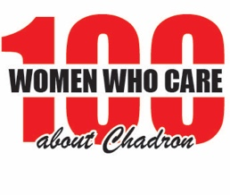
NOMINATION FORM
I, ______________________________________, a member in good standing with 100 Women Who Care About Chadron, nominate the following organization to be considered for the group’s next impact award:
Organization Name: _________________________________________________
Organization Address/Phone/Website: _________________________________
Is the organization a registered 501(c)(3) and able to provide tax receipts? ____
Who does the organization serve? Does it serve residents of Dawes County? ___________________________________________________________________
___________________________________________________________________
Organization Mission Statement: _______________________________________
___________________________________________________________________
How would the impact award be used? ________________________________
__________________________________________________________________
__________________________________________________________________
What is your relationship to the organization? ____________________________
If awarded the impact award, would someone from the organization be available to speak at our next meeting to describe the impact of the donated funds? _______
Does the organization agree NOT to sell, give, or use our membership’s contact information for solicitation by themselves or other organizations? __________
Please submit this nomination form at least two weeks in advance of the meeting to 100womenchadron@gmail.com. Thank you!

