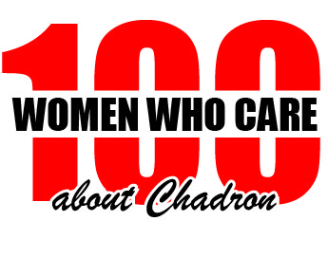
100 Women Who Care About Chadron
Registration & Commitment Form

Commitment: With my signature below, I am agreeing that the information I provide below is accurate and true. I am pledging to participate in 100 Women Who Care About Chadron and I am making a personal commitment to contribute $100 each calendar year to local causes serving Dawes County, Nebraska. I agree to donate to the cause selected by the group’s majority vote. If I am unable to attend a meeting, I will either send my check with another attending member to deliver on my behalf, or provide to a member of the steering committee within five days after the meeting. I also acknowledge that photographs and videos taken at events and meetings may include my image and may be used in promotional materials for 100 Women Who Care About Chadron.
I understand my personal contact information is strictly confidential and I understand it will not be shared or distributed to an outside third party without my expressed consent. If 100 Women Who Care About Chadron chooses to publish a Membership Directory, I agree that my contact information be included in that directory. Yes____ No____

Member:
First Name Address

Last Name City ST Zip

Best Phone Number Email Address

Date Signature

Completed Commitment Forms may be scanned and sent via e-mail to 100womenchadron@gmail.com or forms may be completed and turned in at a meeting. (Should you wish to discontinue membership at any time after your first time commitment, please send an e-mail to 100womenchadron@gmail.com indicating your withdrawal.)

